* **BackBox** **-**

Azure Deployment Guide

# Method 1: Deploy using Powershell

1. Open powershell
2. Navigate to “local-scripts” in “ClientDeployments” folder.
3. Make sure AzureRM Module is installed, execution policy is not restricted
   * Get-Module azurerm -ListAvailable
   * Get-ExecutionPolicy
4. Edit parameters in azuredeploy.parameters file
   * if you are using existing VNET change the parameters file under “BackBox-template-existing-vnet” folder.
     + existingVirtualNetworkName
     + existingVirtualNetworkResourceGroup
     + location
     + optional: vmSize if need to increase Cpu and memory
     + link to Azure vm sizes: <https://docs.microsoft.com/en-us/azure/virtual-machines/windows/sizes-general>
     + optional: vmName
     + osDiskVhdUri should stay null
   * in case you are using new VNET change the parameters file under “BackBox-template-new-vnet” folder.
5. run .\backbox-localDeployment.ps1
6. after deployment is completed navigate to “Network intrfaces” and select backbox NIC, under IP configuration change IP from Dynamic to Static

examples:

* for help type: help .\BackBox-LocalDeployment.ps1 -Examples
* .\backbox-localDeployment.ps1 -location “eastus” -vnetStatus “Existing”
* .\backbox-localDeployment.ps1 -location “westus” -vnetStatus “New”

# Method 2: Deploy using Azure portal

1. Login Azure Portal.
2. Click on cloud shell  button at the top pane and choose Powershell.
3. Copy BackBox-PortalDeployment.ps1 content from “portal-scripts” folder and paste it in the Cloud shell window, the script might take a few minutes.
4. After the script has been completed you will receive a URI, copy it.
5. in the search box at the top pane write “Deploy a custom template” and click on the service below.
6. choose “**Build your own template in the editor**”, under “Learn about template deployment”.
7. If you already have a VNET use BackBox-template-existing-vnet template, unless use BackBox-template-new-vnet
8. Click on “Load File” at the top pane, select AzureDeploy.json and “Save”.
9. Click on “Edit parameters” and “Load File”, select AzureDeploy.parameters.json and “Save”.
10. In “Os Disk Vhd Uri” field paste the URI from step 4
11. Change the other parameters as you need
12. Approve Terms and conditions
13. Click on Purchase

## Appendixes:

5.

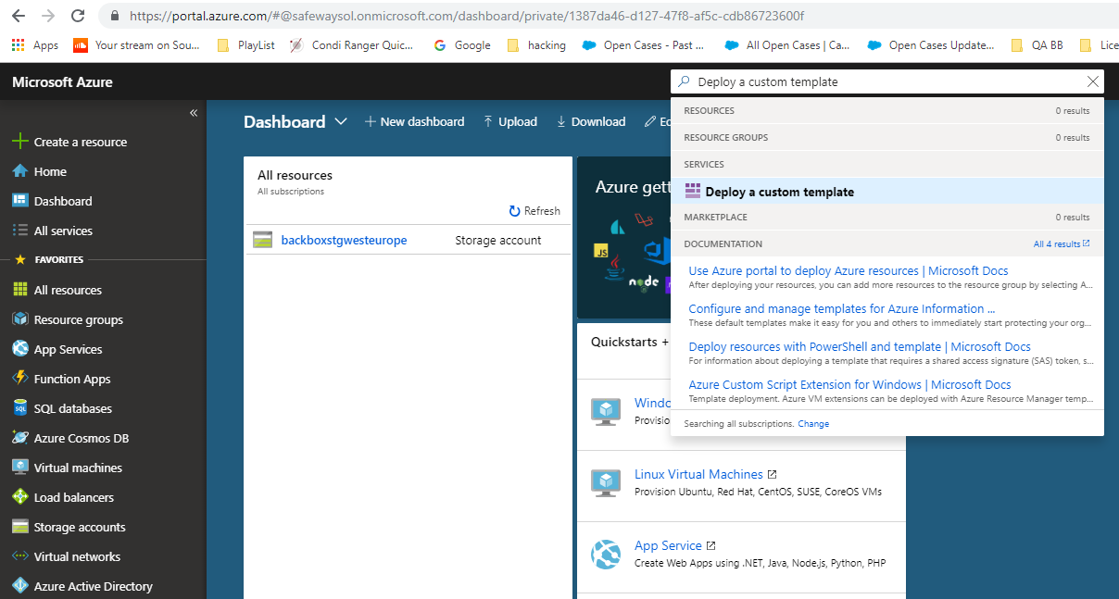

6.

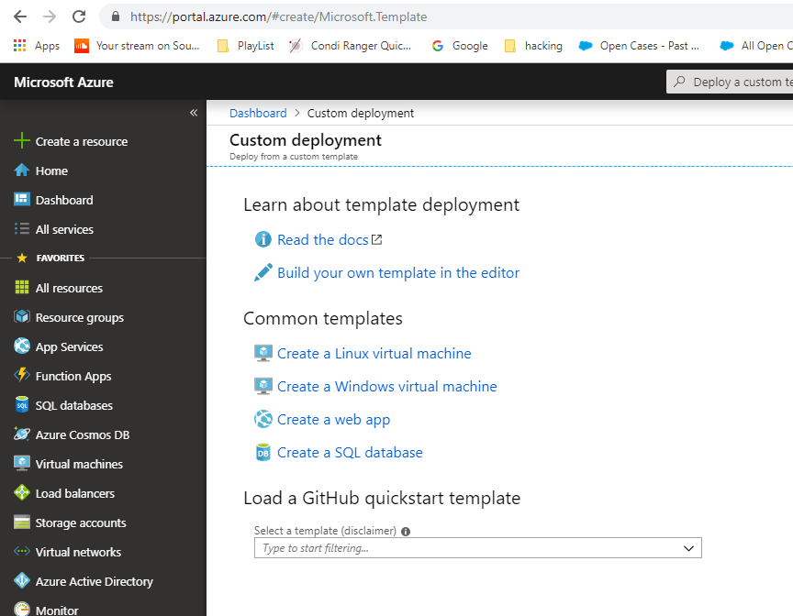

7.

